“Where She Belongs:” Overcoming Obstacles in the California Women’s Suffrage Movement and Beyond

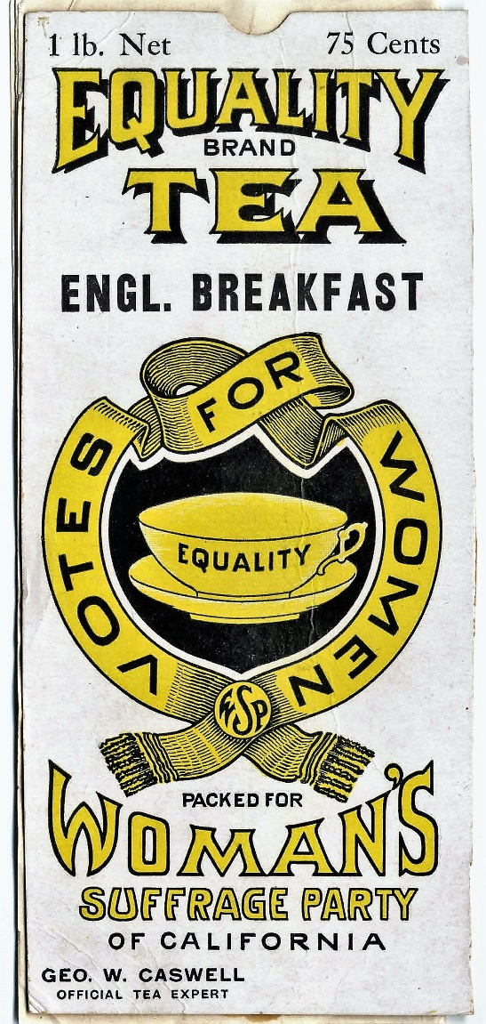
Equality Brand Tea, TM# 5153 (1910), California State Archives, Office of the Secretary of State, Sacramento, California.
A learning resource from the California State Archives

Description:
This activity guide will help students think critically about the challenges that women faced during the Women’s Suffrage Movement in California and beyond. The title, “Where she belongs,” is quoted from California State Senator J. B. Sanford’s 1911 argument against women’s suffrage from the State Archives collection. Students will analyze State Senator J. B. Sanford’s 1911 argument by comparing it to a contemporary article and reflect on whether those prejudices and biases still hold relevance. In addition, students will learn about the role of women of color in the Women’s Suffrage Movement and will compare it with the continued challenges that they face today in political leadership roles. Lastly, students will learn about historical and contemporary voting restrictions to better understand present issues around voting rights.

Grade Levels:
High School (9-12)

Time:
2 hours
Table of Contents
Title page: "Where She Belongs:” Overcoming Obstacles in the California Women’s Suffrage Movement and Beyond 1
Description 2
Grade Levels 2
Time 2
Curriculum Standards 3
Historical and Social Science Content Standards (Grades 9-12) 3
California History Social Science Framework (Grade 11) 3
California Common Core Standards (Grades 11-12) 3
Learning Activities 4
A.) Past attitudes towards women’s suffrage and present attitudes towards women in political leadership roles 4
Directions 4
B.) Explore the role of women of color in the Women’s Suffrage Movement and the challenges they face in today’s political landscape 6
Appendix 8

Curriculum Standards:

Historical and Social Science Content Standards (Grades 9-12)
Pg. 40-41: Analysis Skills: Chronological and Spatial Thinking, 1; Historical Research, Evidence, and Point of View, 2; Historical Interpretation, 1

California History Social Science Framework (Grade 11)
Pg. 388: Why did women want the right to vote, and how did they convince men to grant it to them?

California Common Core Standards (Grades 11-12)
Pg. 80-89: Key Ideas and Details (11-12): 1-3; Integration of Knowledge and Ideas (11-12): 7-9; Research to Build and Present Knowledge (11-12): 9

Learning Activities

Past attitudes towards women’s suffrage and present attitudes towards women in political leadership roles.
Directions: Read California State Senator J. B. Sanford’s 1911 statement (see appendix) opposing women’s voting rights and the World Economic Forum’s article, “Why didn’t the United States elect a female president (2016)?”
- Compare and contrast the two sources by looking specifically at the following themes: gender roles, representation of women in politics, and arguments used to disapprove of women’s role in politics.
- What are the arguments of the two articles?
- Using World Economic Forum’s article as a reference, are the arguments from the 1911 document still relevant in today’s political environment? Why or why not?

Explore the role of women of color in the Women’s Suffrage Movement and the challenges they face in today’s political landscape.

Directions:
- Read NPR’s article on “Yes, Women Could Vote After The 19th Amendment — But Not All Women. Or Men” to learn about the contributions and challenges faced by the women of color in the suffrage movement.
- Review the data below on the “Political representation of women in the U.S. Congress and California State Legislature.”
- Review the State Archives’ online exhibit, “On the Road to Ratification” to understand the voter restrictions of the past and compare it with present voter restrictions in the “Restricted Voter Access” section below.

Representation of Women in the U.S. Congress (2022) and California State Legislature (2021-2022 session)

Women Politicians in the U.S. Congress
- Total number of seats held by women in the U.S. Congress: 145 of 535 (27%)
- Number of Caucasian women: 95
- Number of Asian American/Pacific Islander women: 10
- Number of African American women: 26
- Number of Latina women: 14
- Number of Native American/Alaska Native/Native Hawaiian women: 1
- Number of Middle Eastern/North African women: 1

Women politicians in the California State Legislature
- Total number of seats held by women in the California State Legislature: 38 of 120 (32%)
- Number of Caucasian women: 15
- Number of Asian American/Pacific Islander women: 1
- Number of African American women: 3
- Number of Latina women: 19
- Number of Native American/Alaska Native/Native Hawaiian women: 0
- Number of Middle Eastern/North African women: 0
Sources: Center for American Women and Politics and California State Library

Restricted Voter Access
- 2013: Supreme Court rules that parts of Voting Rights Act of 1965 are unconstitutional. As a result, several states with a history of voter discrimination do not have to get preclearance from the Department of Justice if they want to change their voting laws.
  - This ruling weakened Voting Rights Act of 1965 and made it easier for states to pass restrictive voting laws.
- 2021: After the Presidential election of 2020, several states passed restrictive voting laws such as ID requirements, penalties, and restrictions on mail-in voting.
- According to several scholarly studies, these laws disproportionately affect communities of color.

Questions
- What were the challenges faced by women of color in the Women’s Suffrage Movement?
- How does the legacy of the past still affect the participation of women of color in politics? How can we address this issue?
- How are voting restrictions today different from those in the 19th and first half of the 20th century? What is the effect of voting restrictions, especially upon communities of color?

Appendix
Argument Against Women's Suffrage, 1911
Prepared by J. B. Sanford, Chairmen of Democratic Caucus
ARGUMENT AGAINST SENATE CONSTITUTIONAL AMENDMENT NO. 8
Suffrage is not a right. It is a privilege that may or may not be granted. Politics is no place for a woman consequently the privilege should not be granted to her.
The mother's influence is needed in the home. She can do little good by gadding the streets and neglecting her children. Let her teach her daughters that modesty, patience, and gentleness are the charms of a women. Let her teach her sons that an honest conscience is every man's first political law; that no splendor can rob him nor no force justify the surrender of the simplest right of a free and independent citizen. The mothers of this country can shape the destinies of the nation by keeping in their places and attending to those duties that God Almighty intended for them. The kindly, gentle influence of the mother in the home and the dignified influence of the teacher in the school will far outweigh all the influence of all the mannish female politicians on earth.
The courageous, chivalrous, and manly men and the womanly women, the real mothers and home builders of the country, are opposed to this innovation in American political life. There was a bill (the Sanford bill) before the last legislature which proposed to leave the equal suffrage question to women to decide first before the men should vote on it. This bill was defeated by the suffragettes because they knew that the women would vote down the amendment by a vote of ten to one.
The men are able to run the government and take care of the women. Do women have to vote in order to receive the protection of man? Why, men have gone to war, endured every privation and death itself in defense of woman. To man, woman is the dearest creature on earth, and there is no extreme to which he would not go for his mother or sister. By keeping woman in her exalted position man can be induced to do more for her than he could by having her mix up in affairs that will cause him to lose respect and regard for her. Woman does not have to vote to secure her rights. Man will go to any extreme to protect and elevate her now. As long as woman is woman and keeps her place she will get more protection and more consideration than man gets. When she abdicates her throne she throws down the scepter of her power and loses her influence.
Woman suffrage has been proven a failure in states that have tried it. It is wrong. California should profit by the mistakes of other states. Not one reform has equal suffrage effected. On the contrary, statistics go to show that in most equal suffrage states, Colorado particularly, that divorces have greatly increased since the adoption of the equal suffrage amendment, showing that it has been a home destroyer. Crime has also increased due to lack of the mothers in the home.
Woman is woman. She cannot unsex herself or change her sphere. Let her be content with her lot and perform those high duties intended for her by the Great Creator, and she will accomplish far more in governmental affairs that she can ever accomplish by mixing up in the dirty pool of politics. Keep the home pure and all will be well with the Republic. Let not the sanctity of the home be invaded by every little politician that may be running up and down the highway for office. Let the manly men and the womanly women defeat this amendment and keep woman where she belongs in order that she may retain the respect of all mankind.
J. B. Sanford, Senator, 4th District.
State Senator J. B. Sanford’s statement opposing women’s voting rights, 1911 Special Election Records, California State Archives, Office of the Secretary of State, Sacramento, California.

