Windows Into the Past:

Exploring Photographs in Archives
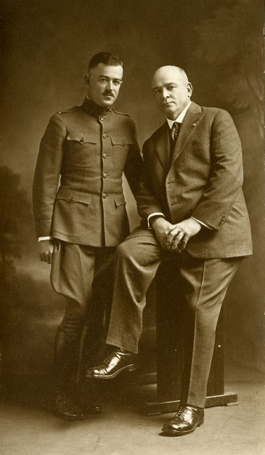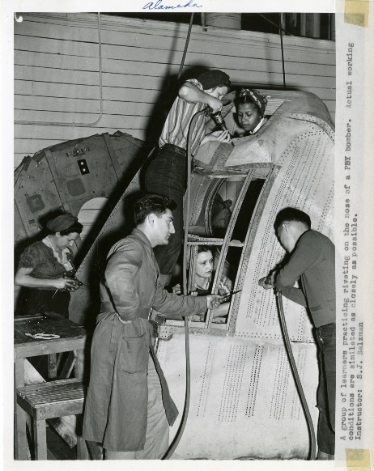
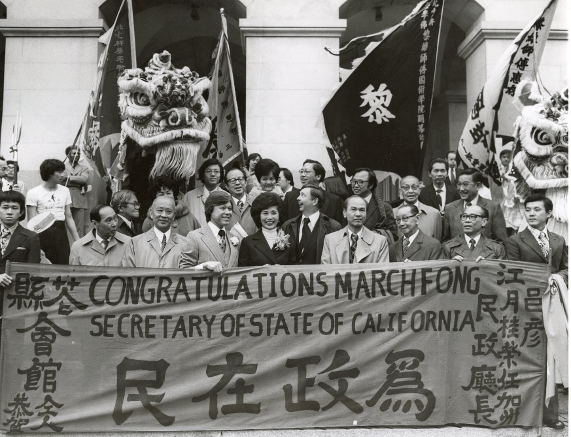
A learning resource from the California State Archives, a division of the Secretary of State’s Office
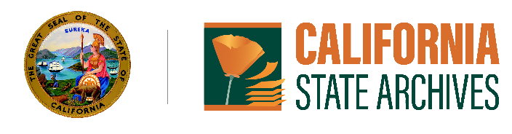

Description
Students will explore the importance of visual communication as they learn about different eras of photography and key points to consider when analyzing a photograph. After watching videos on the history of photography, students will examine and compare photographs from various historical periods from the California State Archives and apply what they have learned through a series of activities and questions focused on analyzing and understanding the value of photographs and primary source documents in historical study.

Grade Levels
7-12

Standards
California Arts Content Standards
Visual Arts: Perceive and Analyze an Artistic Work (Prof. VA): Re 7.2; Interpret Intent and Meaning in an Artistic Work (7-12): Re 8
College, Career, and Civic Life (C3) Framework for Social Studies State Standards
Historical Sources and Evidence: By the end of Grade 8 - D2.His.10-13.6-8; D3.2.6-8; By the end of Grade 12 - D2.His.10-13.9-12
Table of Contents
Title Page 1
Description 2
Grade Levels 2
Standards 2
A) Introduction: Photographs in Archives 3
B) Developments in Photography 4
Directions: 4
C) Analyzing a Photograph 5
Directions 5
Questions 6
D) Compare and Contrast Photographs 7
Directions 7
Questions 8
E) Reflection Questions 9

Introduction: Photographs in Archives
The invention of photography allowed people to capture the world around them in a permanent image for the first time, providing an enthralling new way to communicate visually. While photographic processes were innovated many times over the course of the 19th and 20th centuries, each involved light exposure, chemistry, and mechanics to capture a permanent, real-world image. Today, we are more familiar with digital photography and the cameras on our smart phones, which do not require the same time-consuming and labor-intensive manual development processes involved in analogue photography (the traditional, film-based photographic process).
Before cameras, images of people, objects, and places seen in everyday life were conveyed through artistic methods such as painting and drawing. For thousands of years before the first photograph was captured, the camera obscura was at times used to help render such images. The camera obscura, its name Latin for “dark chamber,” in its most basic form, features a small aperture, or opening, that lets light into a dark room or box. The light projects a smaller, upside-down representation of the surrounding real-world scene onto the surface opposite from the opening. Other versions of the camera obscura feature a mirror to reflect the image right-side-up albeit reversed. Although the projection in a camera obscura does not on its own produce a permanent image, photography was developed around this basic concept. The word “photography,” in fact, is derived from Greek words that mean “drawing with light.”
Since its inception photography has been used in a variety of ways, from artistic endeavors and portraiture to cataloging scientific study and documenting events. Documenting current and newsworthy events through photographs, known as photojournalism, was first pursued on a larger scale in the 1860s during the American Civil War. Capturing events as they unfolded on the scene revolutionized news stories printed in papers and magazines, offering audiences never-before-seen, immediate windows into distant events. While the entire spectrum of photograph genres can be found in archival collections, some of the most informative photographs that end up in archives, and more specifically, the California State Archives, are portraiture or photojournalistic images, as are the ones featured in this guide.
After watching primer videos on the history of photography, students will closely examine a selection of portraiture and photojournalistic photographs from the California State Archives to better understand what information they can and cannot gather from, and the advantages and disadvantages of, studying these important types of primary source documents. Just as important as examining textual documents, students will learn that studying photographs offers invaluable, fascinating glimpses into history.

Developments in Photography
Directions In 1949, the George Eastman Museum in New York, named after the inventor of the Kodak camera, became the world’s first photography museum. Take notes as you watch the following videos the Eastman Museum developed from their series on the history of photography. After watching the videos, answer the question below.

How is photography different today than it was in the past centuries?
Before Photography
The Gelatin Silver Process
Digital Photography
*Photographic Process Videos courtesy of George Eastman Museum

Analyzing a Photograph
Directions While you cannot learn everything about a photograph just by looking at it, asking certain questions will help you better analyze and understand the visual evidence while also identifying what parts need further research. Take a minute or two to look closely at Photograph A below from the California State Archives and answer questions 1-4 on the next page. Then, visit our online March Fong Eu exhibit to learn more about the context of the photograph and answer questions 5-7. Identify what visual evidence, if any, supports your answers. A description of Photograph A is available for visually impaired students and Photograph A may be viewed more closely on our website.
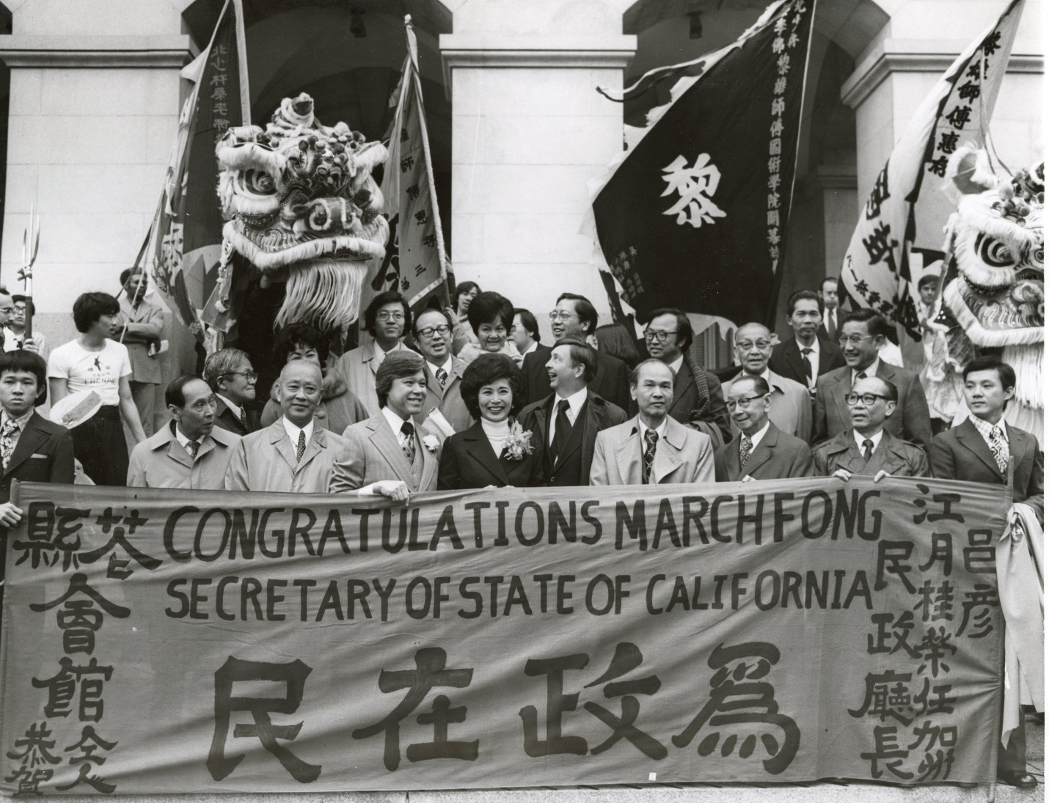
Photograph A

Questions
- Who do you think the photographer and intended audience were? Why do you think this photograph was taken?

- How does this image tell a story? Can you identify any ideas or moods conveyed in the photograph?

- Do you think this photograph would be a credible historical source to use in a historical article? Why or why not?

- Does this photograph successfully communicate a message? If so, what is it?

- Now that you can identify the approximate date of the photograph, can you name any significant event or social movement that occurred around the time or place this photograph was taken that could relate to the photograph? What other historical context would you need to better interpret its meaning?

- After reading more about the context of the photograph from the exhibit, consider any details you have learned about the maker, date, place of origin, intended audience, and purpose of the photograph. How do you think this photograph is useful for historical inquiry?

- Identify how your understanding of the photograph might benefit from additional research - what else would you like to know that you were not able to gather from the image or exhibit?

Compare and Contrast Photographs
Directions
1) Take a few minutes to look carefully at the set of photographs from collections held in the California State Archives below. Then, write basic captions (a descriptive title and educated guess at the date) for each of your images based on only the visual information you gather. Descriptions of each photograph are provided on our website for students with visual impairment to complete this activity. You may also view the photographs on our website.
2) Discover more about the context of each image by exploring the online exhibits that they are featured in: To Keep, Protect, and Preserve: California’s Secretary of State and Essential Functions of Government and Home Front: California During World War II, as well as the original caption adhered to Photograph C.
3) Next, conduct a comparison between the images. For each photograph, consider the genre (portrait or photojournalistic image) general composition (how the visual elements, including, in this case, people, are arranged in the image), context (time, place, and contemporary events that were happening at the time the photograph was taken), and subject matter (who and what is depicted) in your comparison.
4) After making your lists, summarize your comparison in a paragraph.
5) Finally, write new captions for each image based on the information you gathered.
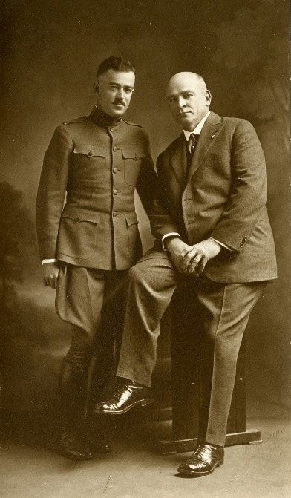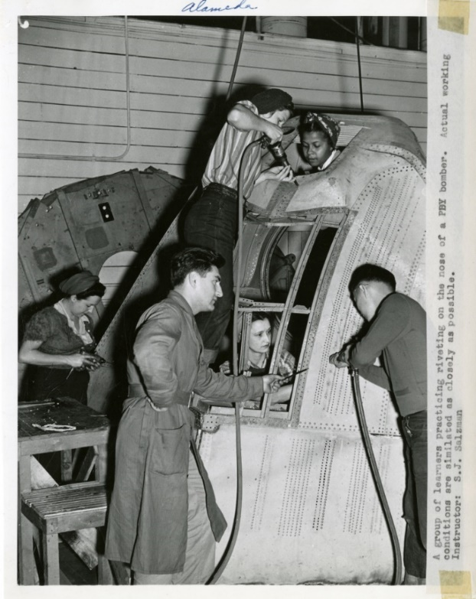
From left to right: Photographs B and C

Questions
- Captions Before Reading the Exhibits:
- Photograph B -

- Photograph C -
- List Similarities Between Photographs

- List Differences Between Photographs

- Compare and Contrast Summary Paragraph

- Captions After Reading the Exhibits:
- Photograph B -

- Photograph C -

Reflection Questions

- How is the information you gather from photographs different than textual documents or that of other visual records, such as paintings or drawings? What are some advantages and disadvantages in using each type of historical record?
- What information were you able to gather through close examination of the photographs alone and what contextual information is necessary to gather elsewhere? What other primary or secondary sources might help you better understand these photographs?
- Explain how your understanding of a historical moment expands after viewing a photograph that was taken during that time.
- What was at least one main difference you noticed between the portrait and photojournalistic photograph during your comparison?
- Why is examining photographs in archives valuable to students and historians?

